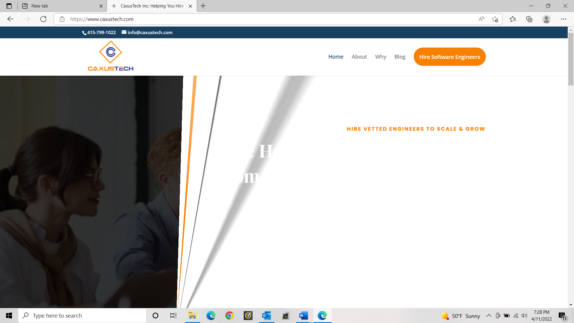

1)While opening the pages opens with this irregular flashing ( it’s an error that needs to be fixed across the website, all pages

2)Change the “Blog” page name to “Resources” and hide the page…..I need to work on this later

3)Make the “ Hire Talent” Page like this : [Schedule Your Free Strategy Session - KnowledgeX](https://knowledgex.us/start/)

Just the Calendly page in the blue backdrop

Remove all these contents

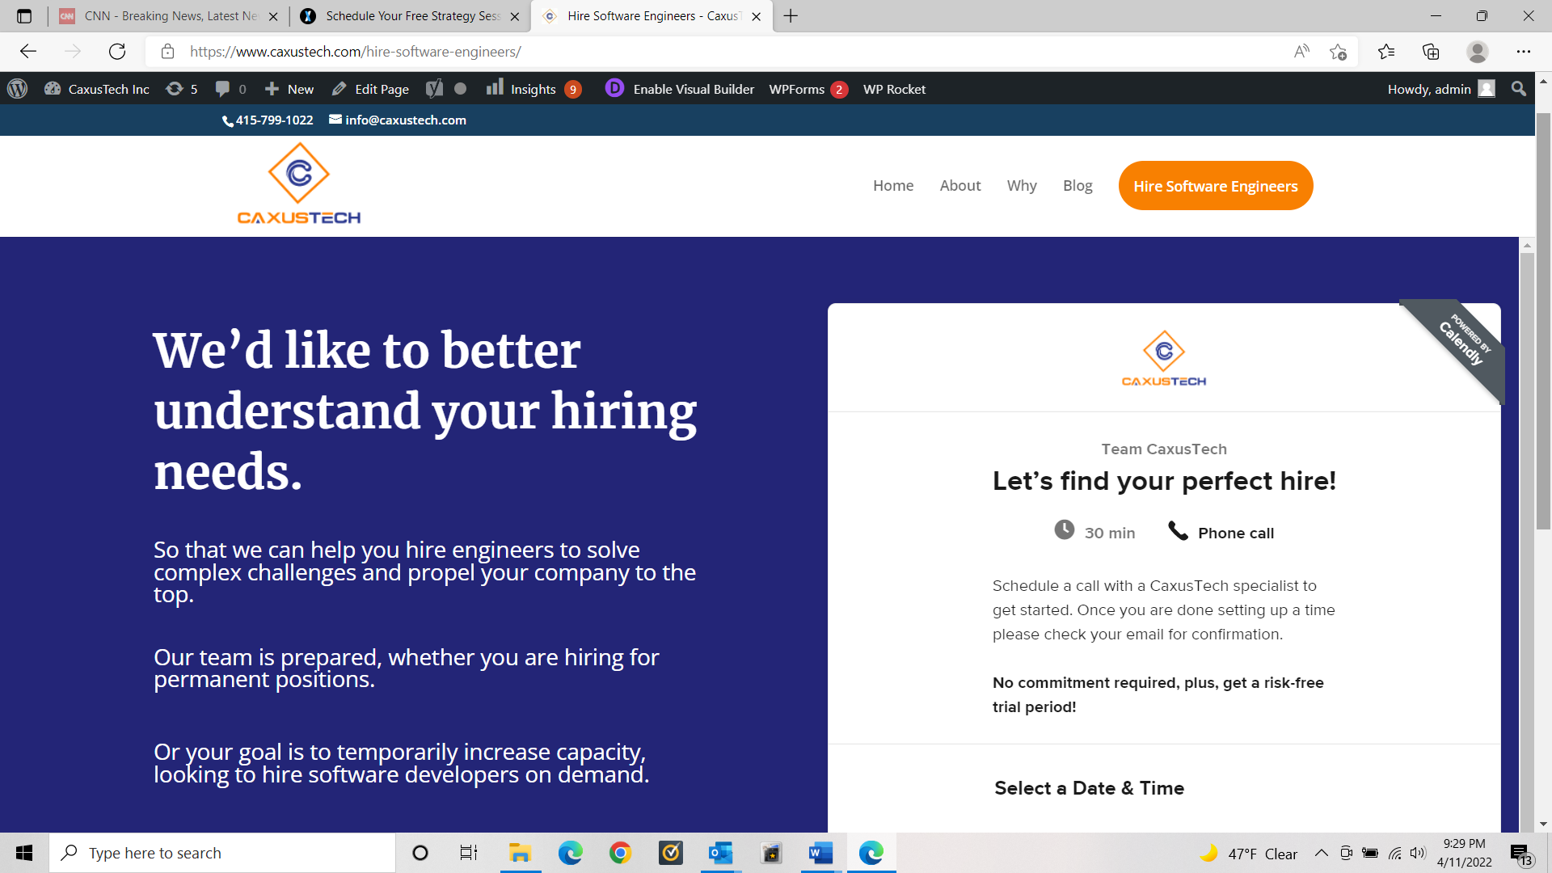

4)Remove this **Hire Now** Button.



5)Change the page name to “**Hire Talent**” from “Hire Software Engineers”

6)Not sure if it’s possible to Make the color of all pages names in dark blue ( as the color of blue in the logo)



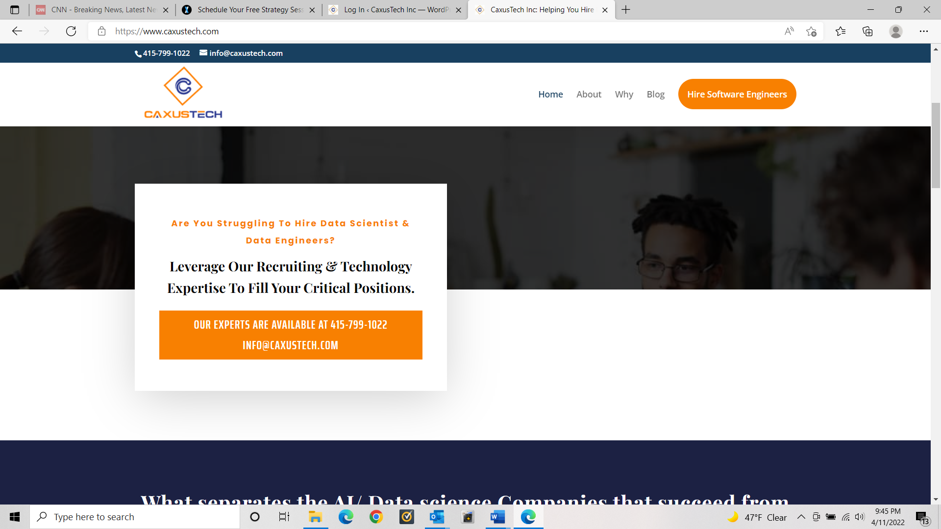

7)I have changed the content of this box….needs this to look more balanced “font-wise”. Make the Orange box just a content , no hyper link or Clickable button.

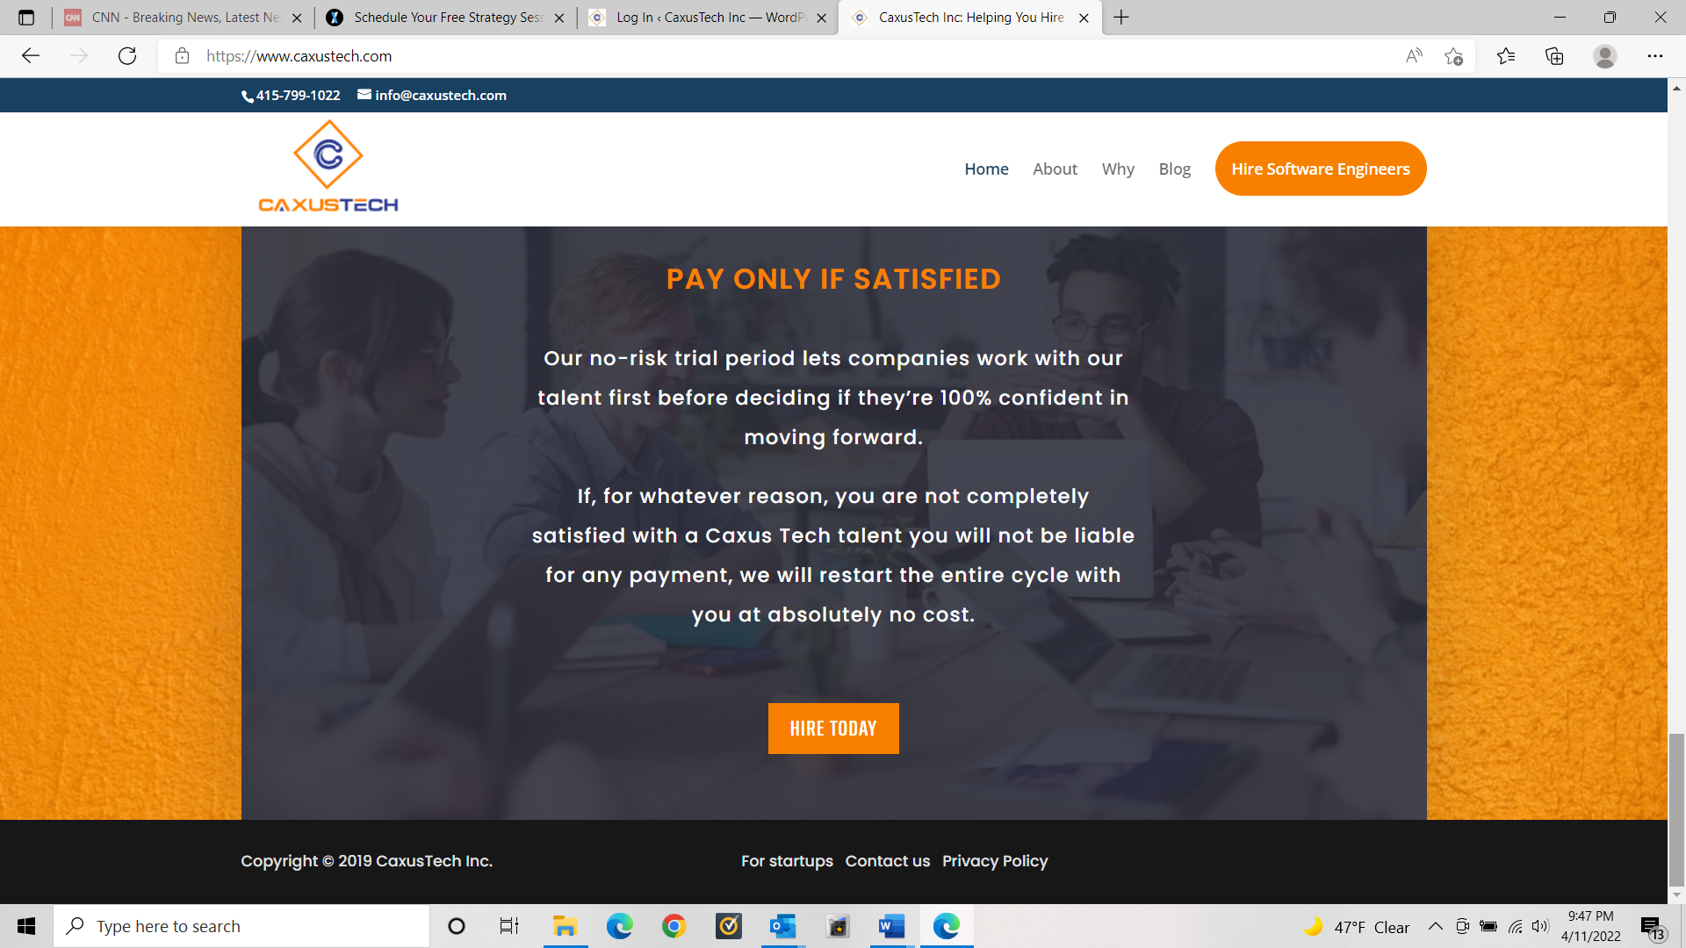

8)Content in the **orange box** and remove the clickable button

Connect with our reps to explore if we're a good fit to work together: 415-799-1022 [info@caxustech.com](mailto:info@caxustech.com)

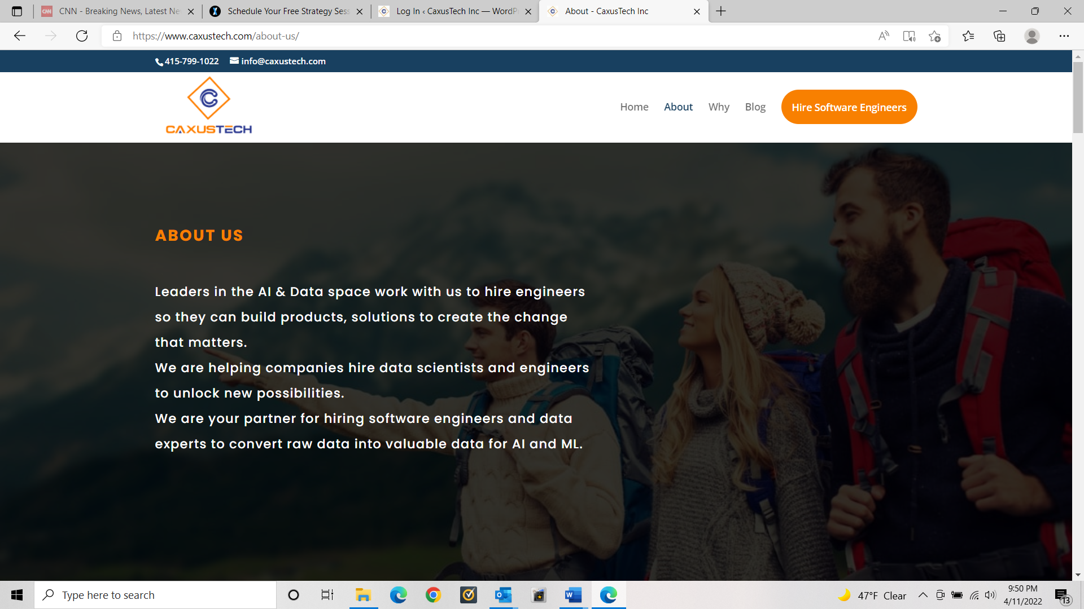

9)If the fonts can be more aligned ….I think it looks little off from previous pages. not a big deal if it stays the way it is.

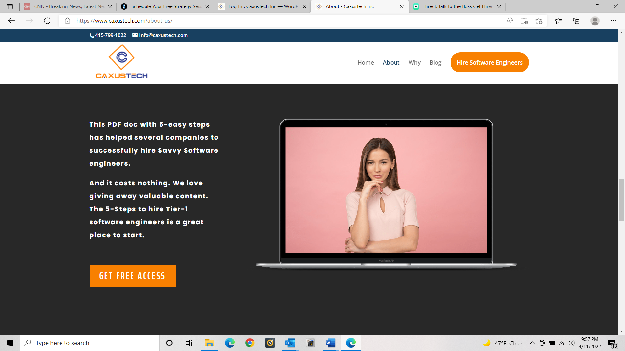

10)Content for this Section , similar to the below box

In a highly competitive tech talent market, it’s hard to capture the attention of in-demand tech professionals. But we know how to capture their attention and inspire them to take a step towards your company

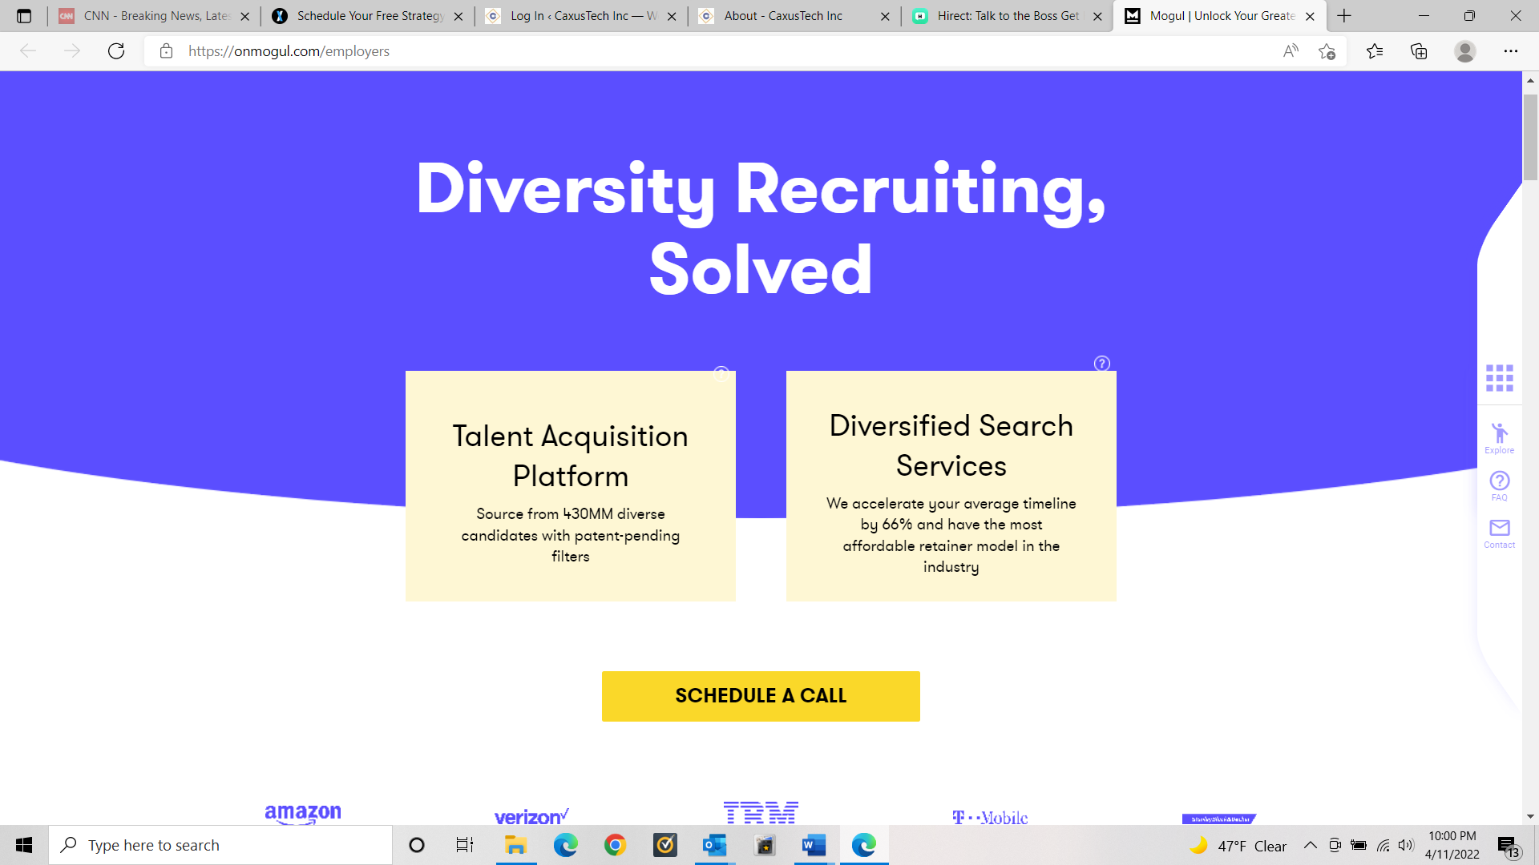

**Find the right tech candidates, fast**

Access a pool of candidates using our in-house AI technology diversity filters for comprehensive and unlimited sourcing capabilities

**Direct Access to Diverse Candidates’ Contact Information**

Higher response rates than in-platform messaging could ever deliver

Connect with us at : phone and email

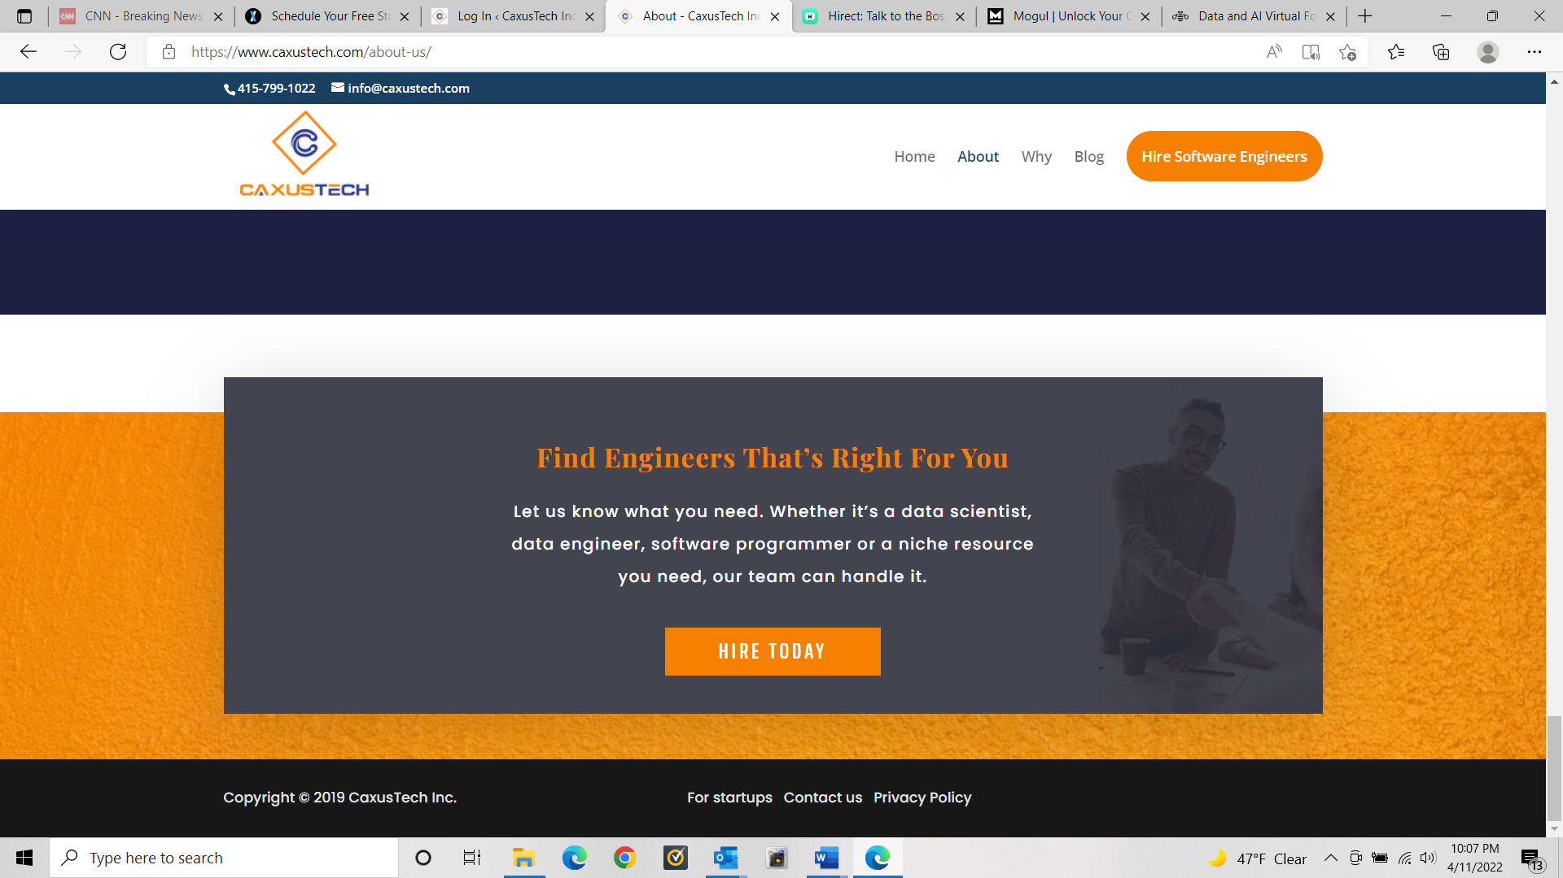

11) in the orage box content and reving the clickable button : “We are available at : Phone & email”

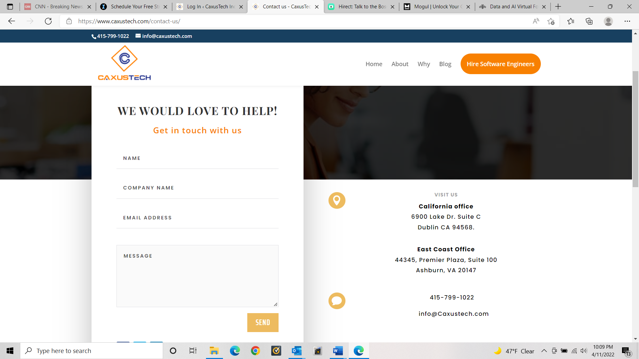

12)Need to add a CAPTCA or some for security …because it’s attracting a lot of junk . OR me just add the Calendly button here

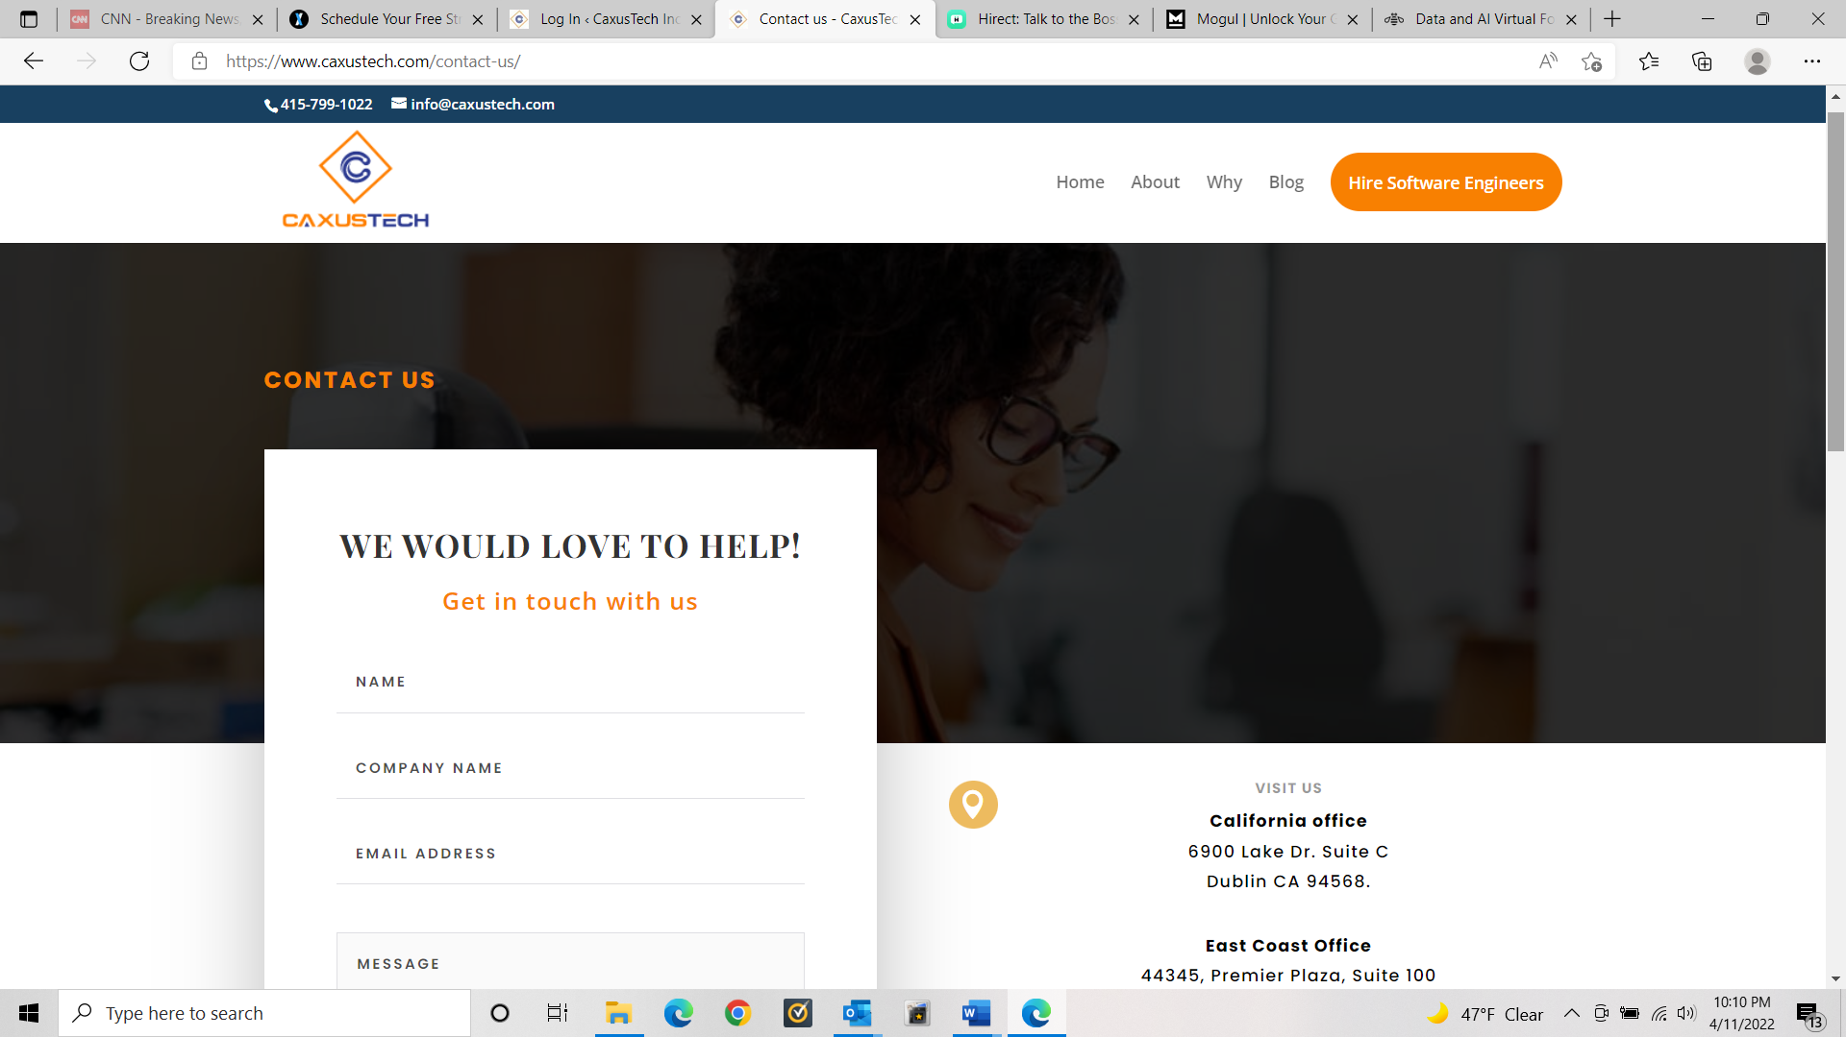

13)Change The “Why” Page name to ***“Why CaxusTech”***

14)This “**Privacy policy”** page on the lower side of has compatibility issue….the text doesn’t fit well…I keep getting messages from google that the page is not compatible….Needs to be fixed

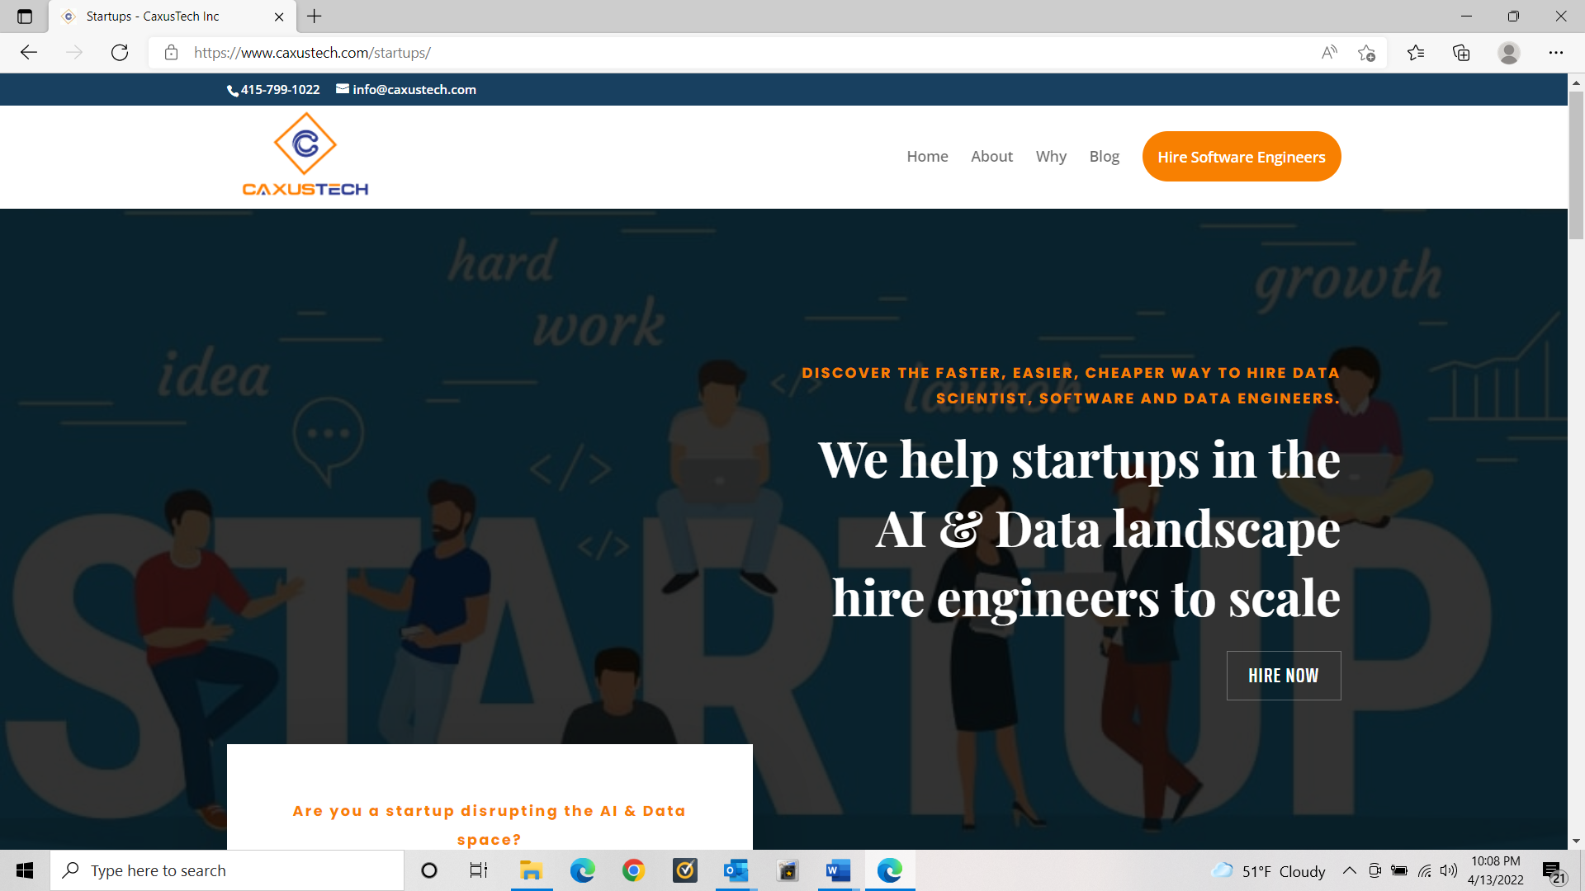

15)Some content changes on this Startup Page and removing the clickable buttons to simple texts

16) All the pages open with sudden jerk….they aren’t opening smooth. Needs to be fixed

17) not sure if could be done - if anything can be done to make it more mobile compatible….